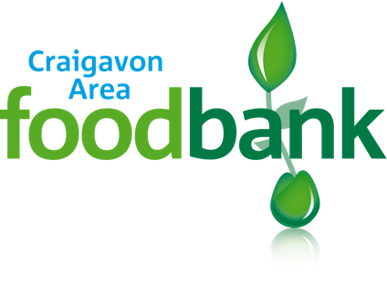

Data Privacy Statement

We use your personal information to help understand your needs and provide you with emergency food. The foodbank and the Trussell Trust have a legitimate interest to use information about you to show how foodbanks are being used and why they are needed.

Access to your information is restricted and can only be seen by the agencies who refer you, and authorised people in the Trussell Trust food bank network who need to do so for food bank reasons.

To find out more about your rights or about how we keep your information safe, please refer to the Data Protection Policy on our website or ask the food bank to give you a copy.

